**Model Development Phase Template**

|  |  |
| --- | --- |
| Date | 15 July 2024 |
| Team ID | 740684 |
| Project Title | Space X Falcon 9 First Stage Landing Success Predictor |
| Maximum Marks | 4 Marks |

**Initial Model Training Code, Model Validation and Evaluation Report**

The initial model training code will be showcased in the future through a screenshot. The model validation and evaluation report will include classification reports, accuracy, and confusion matrices for multiple models, presented through respective screenshots.

**Initial Model Training Code:**

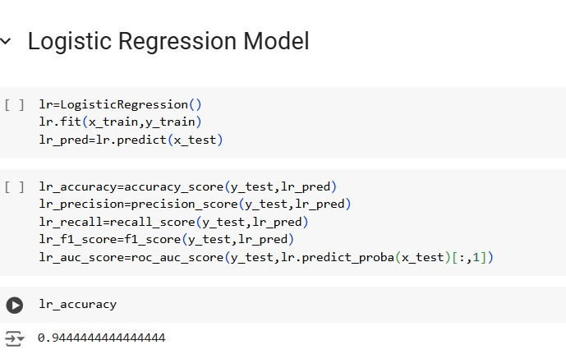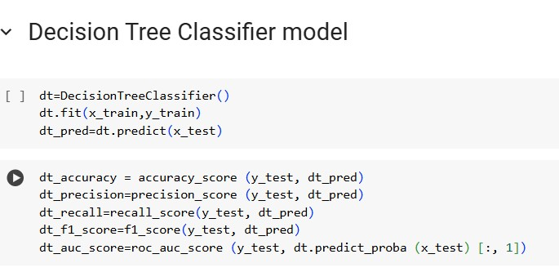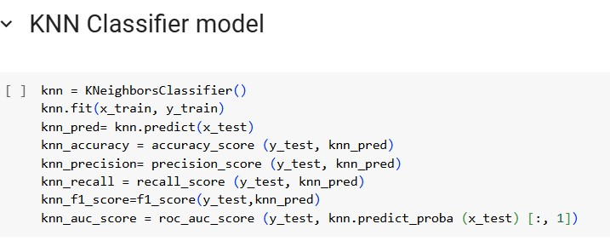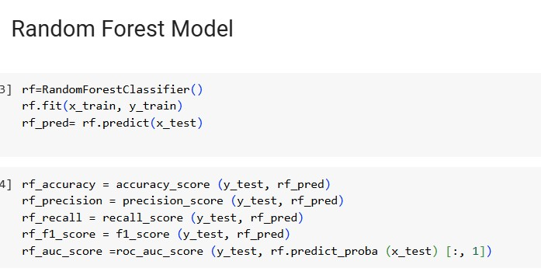

**Model Validation and Evaluation Report:**

|  |  |  |  |
| --- | --- | --- | --- |
| **Model** | **Classification Report** | **F1 Score** | **Confusion Matrix** |
| Logistic  Regression |  | 96% |  |
| Decision Tree |  | 96% |  |

|  |  |  |  |
| --- | --- | --- | --- |
| KNN |  | 96% |  |
| Random  Forest |  | 96% |  |